Puzzle-Based Rearrangement

Definition
# Source: AI Source: Provided by: [Data Path: Persons Table -> ID Column: 1, Name_En Column: Motasem Essam] -> From: [ChatGPT] on [7/25/2026]
Puzzle-Based Rearrangement is a type of geometric figure rearrangement in which a collection of geometric pieces is moved, rotated, reflected, or reordered according to specified rules to achieve a target configuration.
The objective is to assemble the pieces into a required shape while satisfying the puzzle's constraints.

Simple Definition
# Source: AI Source: Provided by: [Data Path: Persons Table -> ID Column: 1, Name_En Column: Motasem Essam] -> From: [ChatGPT] on [7/25/2026]
Puzzle-based rearrangement means moving and arranging geometric pieces according to certain rules to form a required figure.

Example
# Source: AI Source: Provided by: [Data Path: Persons Table -> ID Column: 1, Name_En Column: Motasem Essam] -> From: [ChatGPT] on [7/25/2026]
Rearranging the seven pieces of a tangram puzzle to form a square, triangle, parallelogram, or another polygon.
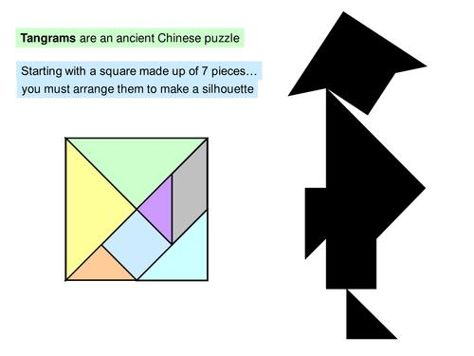

Main Classification of Puzzle-Based Rearrangement
The following is a practical classification based on the puzzle's objective or constraints. These categories can overlap and are not a universally standardized mathematical taxonomy.

1. Target-Shape Puzzle Rearrangement
# Source: AI Source: Provided by: [Data Path: Persons Table -> ID Column: 1, Name_En Column: Motasem Essam] -> From: [ChatGPT] on [7/25/2026]
Pieces are arranged to reproduce a specified target shape.
Example: Using all the pieces of a tangram to form a square without gaps or overlaps.
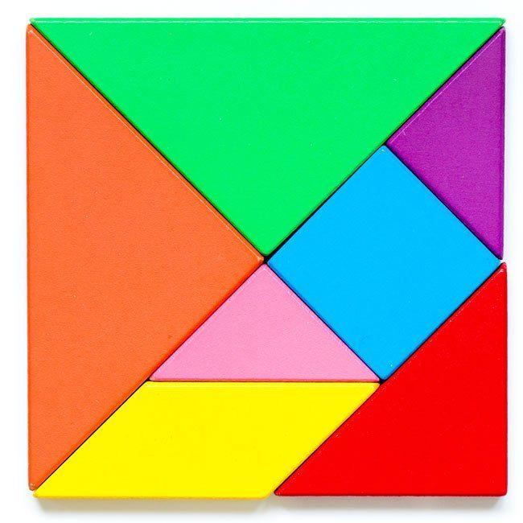

2. Silhouette-Matching Puzzle Rearrangement
# Source: AI Source: Provided by: [Data Path: Persons Table -> ID Column: 1, Name_En Column: Motasem Essam] -> From: [ChatGPT] on [7/25/2026]
Pieces are arranged to match the outline or silhouette of a target figure. The target may be presented only as a solid shape without internal divisions.
Example: Rearranging triangular pieces to fill the outline of an animal or an irregular polygon.
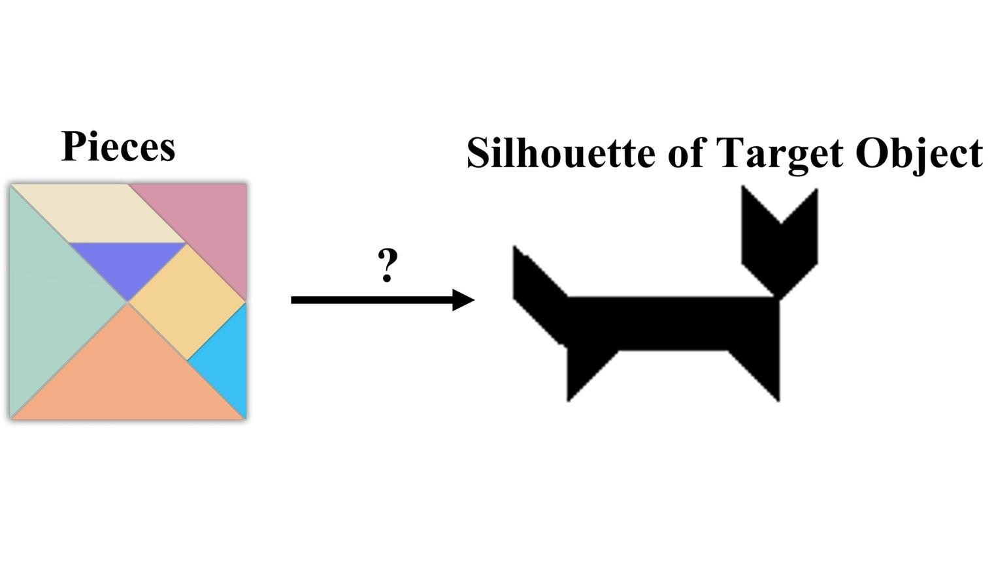

3. Piece-Placement Puzzle Rearrangement
# Source: AI Source: Provided by: [Data Path: Persons Table -> ID Column: 1, Name_En Column: Motasem Essam] -> From: [ChatGPT] on [7/25/2026]
Each piece must be placed in a particular location or orientation to satisfy the puzzle's requirements.
Example: Placing four triangular pieces in designated regions to form a larger square.
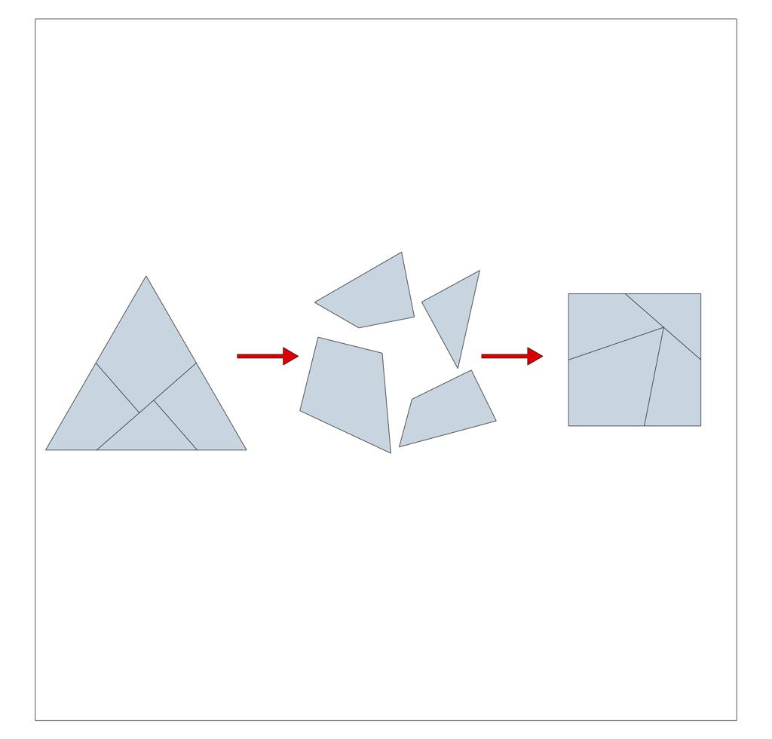

4. Rule-Constrained Puzzle Rearrangement
# Source: AI Source: Provided by: [Data Path: Persons Table -> ID Column: 1, Name_En Column: Motasem Essam] -> From: [ChatGPT] on [7/25/2026]
Pieces must be rearranged while obeying explicit restrictions on permitted movements or placements.
Example: Forming a target polygon while allowing only translations and rotations, with reflections prohibited.
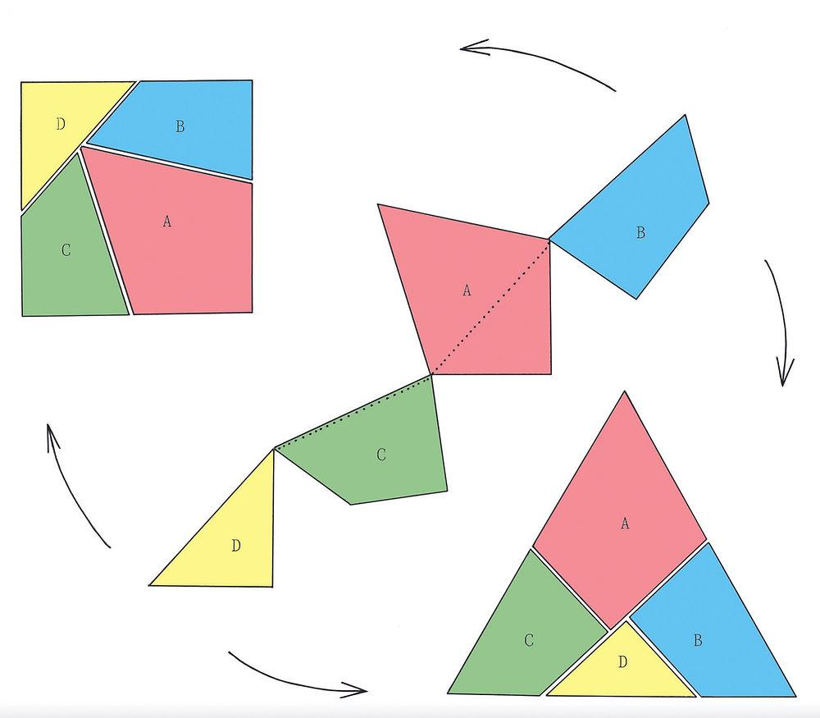

5. Minimum-Movement Puzzle Rearrangement
# Source: AI Source: Provided by: [Data Path: Persons Table -> ID Column: 1, Name_En Column: Motasem Essam] -> From: [ChatGPT] on [7/25/2026]
The target configuration must be achieved using the fewest permitted moves.
Example: Moving only two pieces of a matchstick square arrangement to create a specified new shape.
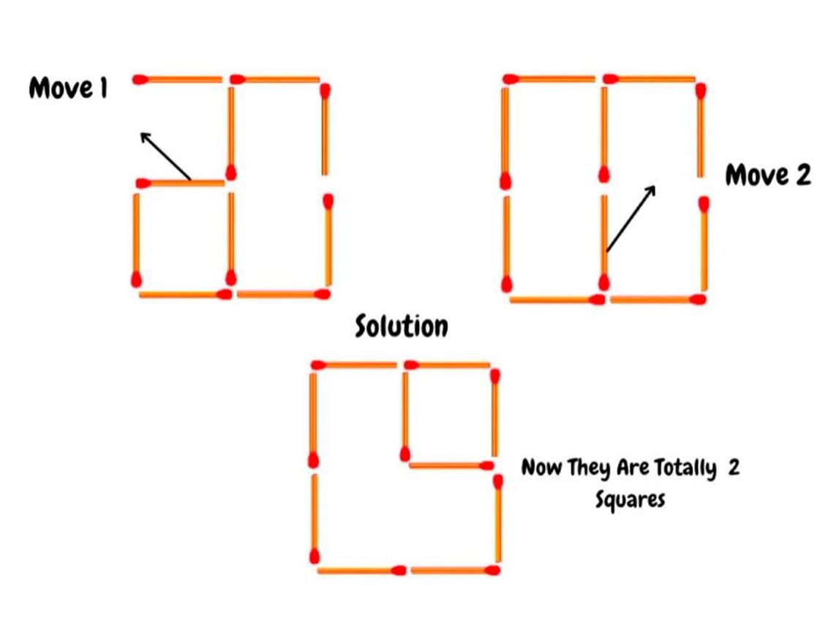

6. Piece-Reordering Puzzle Rearrangement
# Source: AI Source: Provided by: [Data Path: Persons Table -> ID Column: 1, Name_En Column: Motasem Essam] -> From: [ChatGPT] on [7/25/2026]
The puzzle focuses on changing the positions or order of pieces to reach a target arrangement. Depending on the rules, pieces may also be rotated or reflected.
Example: Reordering several triangular pieces to transform a square arrangement into a parallelogram.
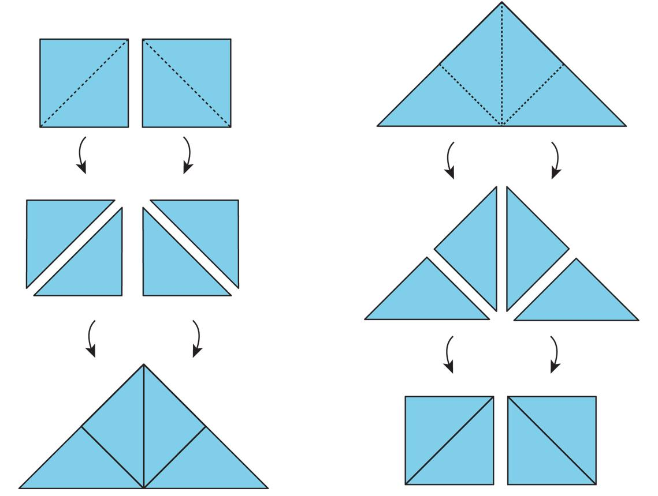

7. Spatial-Relationship Puzzle Rearrangement
# Source: AI Source: Provided by: [Data Path: Persons Table -> ID Column: 1, Name_En Column: Motasem Essam] -> From: [ChatGPT] on [7/25/2026]
Pieces must be positioned to satisfy relationships such as adjacency, alignment, symmetry, or separation.
Example: Arranging identical triangles so that they share specified edges and form a symmetrical hexagon.
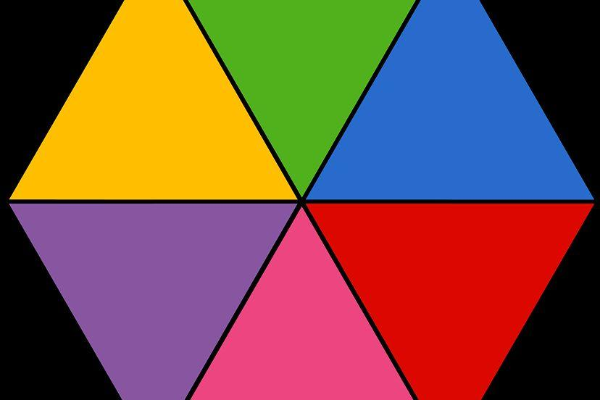

8. Multi-Stage Puzzle Rearrangement
# Source: AI Source: Provided by: [Data Path: Persons Table -> ID Column: 1, Name_En Column: Motasem Essam] -> From: [ChatGPT] on [7/25/2026]
The target is reached through a sequence of intermediate configurations, each preparing for the next step.
Example: First assembling small triangles into a parallelogram, then rearranging that configuration to produce a larger target polygon.
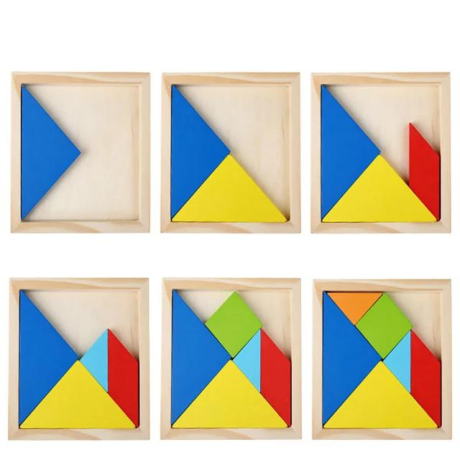

Mathematical Representation
# Source: AI Source: Provided by: [Data Path: Persons Table -> ID Column: 1, Name_En Column: Motasem Essam] -> From: [ChatGPT] on [7/25/2026]
Let the collection of pieces be
$$P=\left\{P_{1},P_{2},…,P_{n}\right\}$$
Let $T$ denote the target shape. The puzzle asks for permitted transformations of the pieces such that their union forms the target:
$$\boxed{\bigcup_{i=1}^{n}{P_{i}}'=T}$$
Here, $P_{i}'$ represents the final position and orientation of piece $P_{i}$.
For a puzzle requiring complete coverage without overlapping interiors:
$$\operatorname{Area}\left(T\right)=\sum_{i=1}^{n}{\operatorname{Area}\left(P_{i}\right)}$$
This area condition is necessary for a perfect assembly, but it is not sufficient by itself: the pieces must also fit the target's geometry and satisfy the puzzle rules.

Detailed Mathematical Example
# Source: AI Source: Provided by: [Data Path: Persons Table -> ID Column: 1, Name_En Column: Motasem Essam] -> From: [ChatGPT] on [7/25/2026]
Suppose a puzzle contains four congruent right triangles, each with perpendicular sides of lengths $3$ and $4$ units.
The area of each triangle is
$$A_{1}=\frac{1}{2}\left(3\right)\left(4\right)=6$$
The total area of the four pieces is
$$A_{\text{total}}=4\left(6\right)=24$$
If the puzzle's target is a rectangle with dimensions $6×4$, its area is
$$A_{T}=6\left(4\right)=24$$
The areas are equal, so the target has the correct area. However, a valid solution must still establish that the four triangles can actually be arranged into that rectangle under the permitted rules.
This illustrates the difference between satisfying an area condition and solving the complete geometric puzzle.

Properties of Puzzle-Based Rearrangement
# Source: AI Source: Provided by: [Data Path: Persons Table -> ID Column: 1, Name_En Column: Motasem Essam] -> From: [ChatGPT] on [7/25/2026]
- Defined objective: A target shape or configuration is specified.
- Piece preservation: The pieces normally retain their shapes and sizes.
- Movement rules: The puzzle may permit or prohibit rotation, reflection, translation, or other operations.
- Constraint satisfaction: The final arrangement must obey all stated rules.
- Geometric compatibility: Edges and regions must fit together appropriately.
- Area conservation: The total area is preserved when the same pieces are used without gaps or overlaps.
- Multiple solutions: Some puzzles admit several valid arrangements; others have only one under their rules.
- Optimization: Certain puzzles ask for the fewest moves or the simplest sequence of operations.

Puzzle-Based Rearrangement vs. Other Types
# Source: AI Source: Provided by: [Data Path: Persons Table -> ID Column: 1, Name_En Column: Motasem Essam] -> From: [ChatGPT] on [7/25/2026]
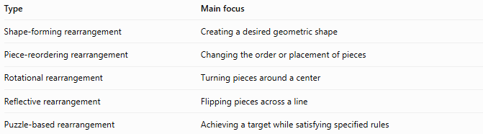
Type | Main focus
Shape-forming rearrangement | Creating a desired geometric shape
Piece-reordering rearrangement | Changing the order or placement of pieces
Rotational rearrangement | Turning pieces around a center
Reflective rearrangement | Flipping pieces across a line
Puzzle-based rearrangement | Achieving a target while satisfying specified rules
Important distinction: Puzzle-based rearrangement is a broader, goal-oriented category. It may involve shape-forming, piece-reordering, rotational, reflective, or positional rearrangement within the same puzzle.

Classification Summary
# Source: AI Source: Provided by: [Data Path: Persons Table -> ID Column: 1, Name_En Column: Motasem Essam] -> From: [ChatGPT] on [7/25/2026]
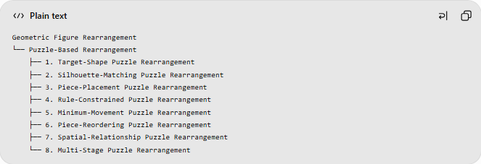
Geometric Figure Rearrangement
└── Puzzle-Based Rearrangement
├── 1. Target-Shape Puzzle Rearrangement
├── 2. Silhouette-Matching Puzzle Rearrangement
├── 3. Piece-Placement Puzzle Rearrangement
├── 4. Rule-Constrained Puzzle Rearrangement
├── 5. Minimum-Movement Puzzle Rearrangement
├── 6. Piece-Reordering Puzzle Rearrangement
├── 7. Spatial-Relationship Puzzle Rearrangement
└── 8. Multi-Stage Puzzle Rearrangement
These are descriptive categories rather than mutually exclusive mathematical classes.

Key Points
# Source: AI Source: Provided by: [Data Path: Persons Table -> ID Column: 1, Name_En Column: Motasem Essam] -> From: [ChatGPT] on [7/25/2026]
- Puzzle-based rearrangement has a defined target and a set of rules.
- Pieces can be translated, rotated, reflected, or reordered when permitted.
- A correct solution must satisfy both the target geometry and the puzzle's constraints.
- Equal total area is necessary for exact coverage but does not guarantee that a solution exists.
- Tangrams, dissection puzzles, matchstick puzzles, and tiling challenges are common examples.

Conclusion
# Source: AI Source: Provided by: [Data Path: Persons Table -> ID Column: 1, Name_En Column: Motasem Essam] -> From: [ChatGPT] on [7/25/2026]
Puzzle-Based Rearrangement is a goal-oriented form of geometric rearrangement in which pieces are manipulated under specified rules to achieve a target configuration. It combines geometric reasoning, spatial visualization, and problem-solving.

